
Parkinson's Disease Dataset Analysis
This dataset, which can be found in https://www.kaggle.com/datasets/rabieelkharoua/parkinsons-disease-dataset-analysis/data, comprises comprehensive health information for 2,105 patients diagnosed with Parkinson's Disease, each uniquely identified with IDs ranging from 3058 to 5162. The dataset includes demographic details, lifestyle factors, medical history, clinical measurements, cognitive and functional assessments, symptoms, and a diagnosis indicator. It is valuable for researchers and data scientists aiming to explore factors associated with Parkinson's Disease, develop predictive models, and conduct statistical analyses.
The categorical features included are encoded as:
- Gender: Male (0), Female (1)
- Ethnicity: Caucasian (0), African American (1), Asian (2), Other (3)
- EducationLevel: None (0), High School (1), Bachelor’s (2), Higher (3)
- DoctorInCharge: this column contains confidential information therefore all samples have taken the value “DrXXXConfid”
Isalos version used: 2.0.6

Step 1: Import data from file
Right click on the input spreadsheet (left) and choose the option “Import from File”. Then navigate through your files to load the one with the Parkinson’s disease data.
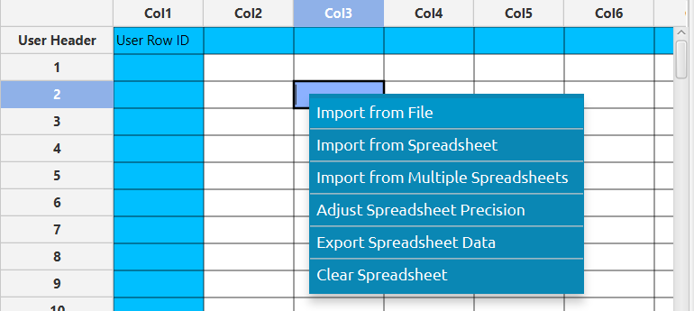

The data will appear on the left spreadsheet.
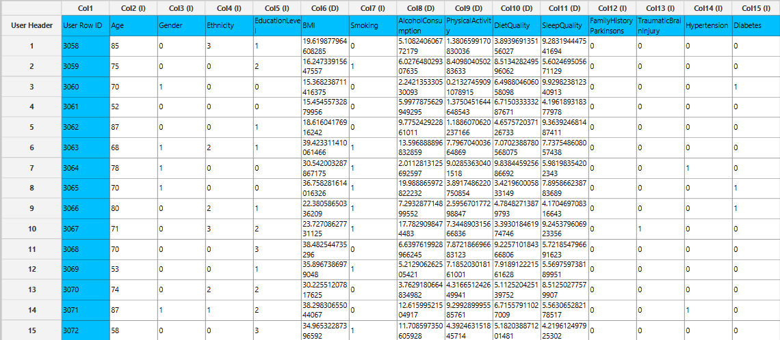

Step 2: Manipulate data
In our dataset there are not any empty values, so we can select all the columns to be used. However, since the column “DrXXXConfid” does not offer any significant information about the Parkinson’s disease diagnosis we will exclude it. On the menu click on Data Transformation $→$ Data Manipulation $→$ Select Column(s) and select all columns except “DrXXXConfid”.
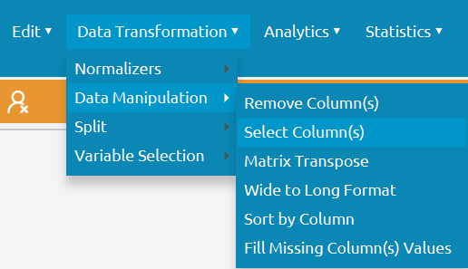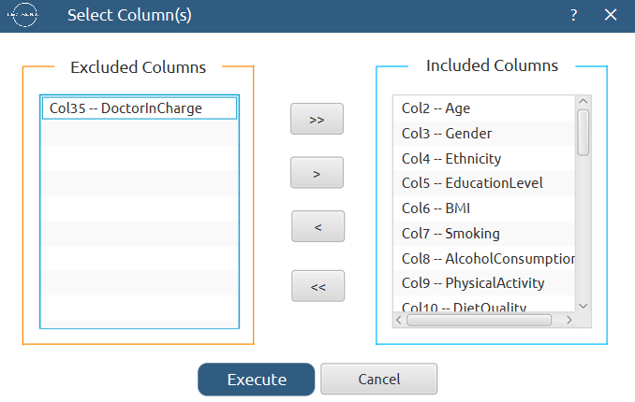

All of the data will appear in the output (right) spreadsheet. This tab can be renamed “IMPORT” by right-clicking on it and choosing the “Rename” option.
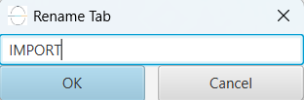

Step 3: Split data
Create a new tab by pressing the “+” button on the bottom of the page with the name “TRAIN_TEST_SPLIT” which we will use for splitting the train and test set.
Import data into the input spreadsheet of the “TRAIN_TEST_SPLIT” tab from the output of the “IMPORT” tab by right-clicking on the input spreadsheet and then choosing “Import from Spreadsheet”.



Split the dataset by choosing Data Transformation $→$ Split $→$ Random Partitioning. Then choose the “Training set percentage” and the column for the sampling as shown below:

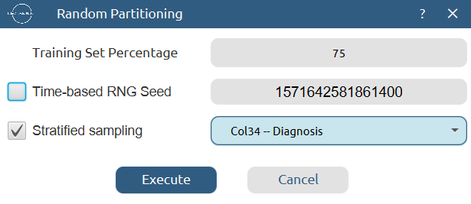

The results will be two separate spreadsheets, “TRAIN_TEST_SPLIT: Training Set” and “TRAIN_TEST_SPLIT: Test Set”, which will be available to import into the next tabs.

Step 4: Normalize the training set
Create a new tab by pressing the “+” button on the bottom of the page with the name “NORMALIZE_TRAIN_SET”.
Import into the input spreadsheet of the “NORMALIZE_TRAIN_SET” tab the train set from the output of the “TRAIN_TEST_SPLIT” tab by right-clicking on the input spreadsheet and then choosing “Import from Spreadsheet”. From the available Select input tab options choose “TRAIN_TEST_SPLIT: Training Set”.

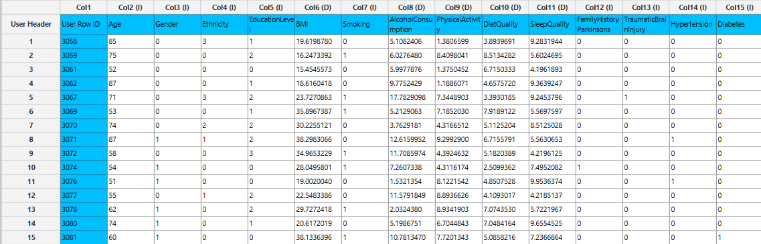

Normalize the data using Z-score: Data Transformation $→$ Normalizers $→$ Z Score and select all columns except the “Diagnosis” target column.
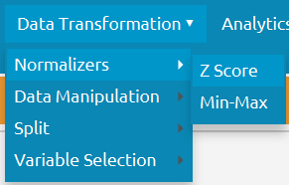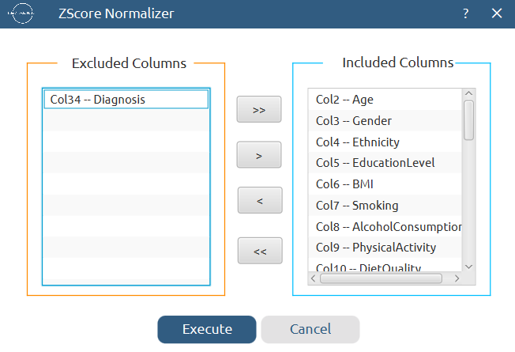

The results will appear on the output spreadsheet.
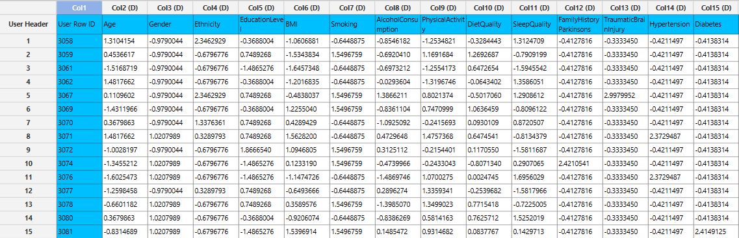

Step 5: Normalize the test set
Create a new tab by pressing the “+” button on the bottom of the page with the name “NORMALIZE_TEST_SET”.
Import into the input spreadsheet of the “NORMALIZE_TEST_SET” tab the test set from the output of the “TRAIN_TEST_SPLIT” tab by right-clicking on the input spreadsheet and then choosing “Import from Spreadsheet”. From the available Select input tab options choose “TRAIN_TEST_SPLIT: Test Set”.

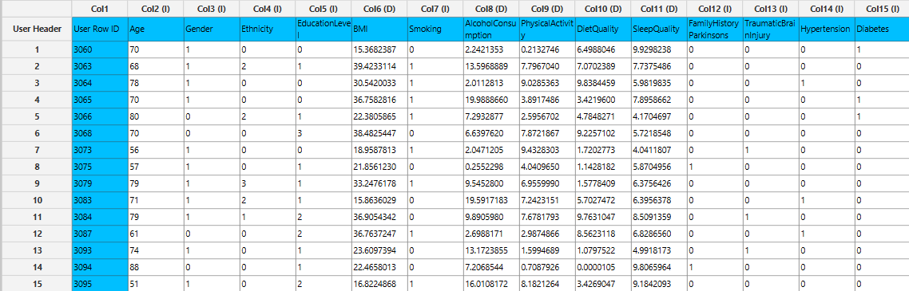

Normalize the test set using the existing normalizer of the training set: Analytics $→$ Existing Model Utilization $→$ Model (from Tab:) NORMALIZE_TRAIN_SET
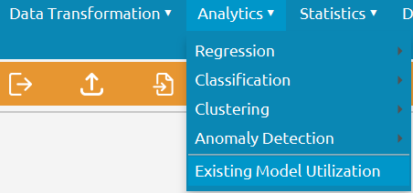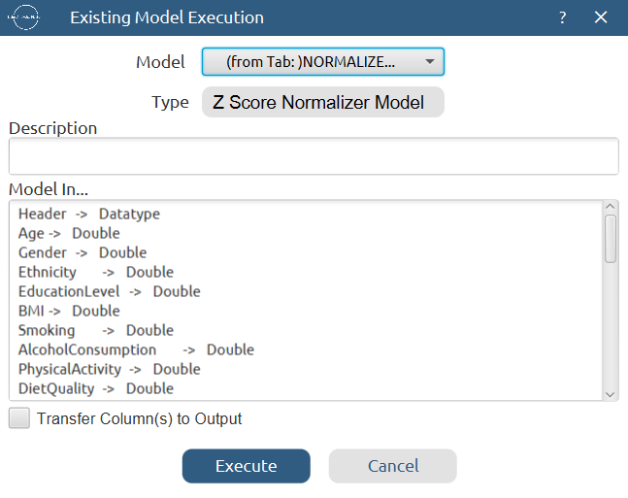

The results will appear on the output spreadsheet.
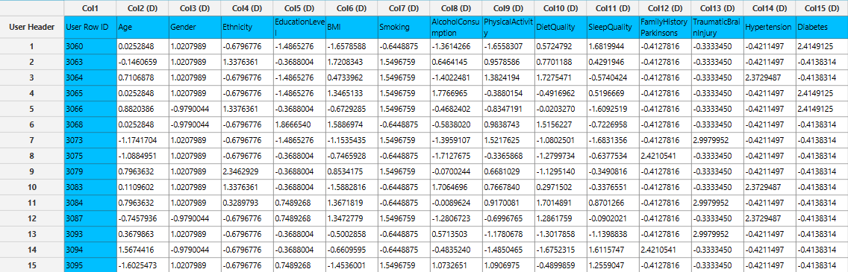

Step 6: Regression Analysis
We want to choose the features that will be the most useful for predicting the Parkinson’s diagnosis. Create a new tab by pressing the “+” button on the bottom of the page with the name “REGRESSION_ANALYSIS”.
Import data into the input spreadsheet of the “REGRESSION_ANALYSIS” tab from the output of the “NORMALIZE_TRAIN_SET” tab by right-clicking on the input spreadsheet and then choosing “Import from Spreadsheet”.
Conduct regression analysis by choosing: Data Transformation $→$ Variable Selection $→$ Regression Analysis
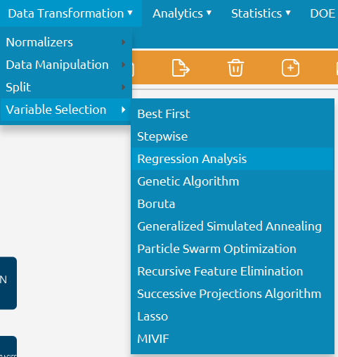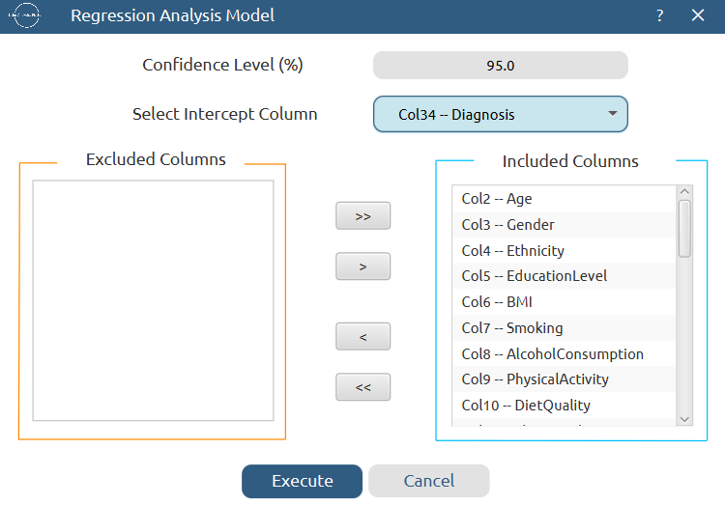

The results will appear on the output spreadsheet.
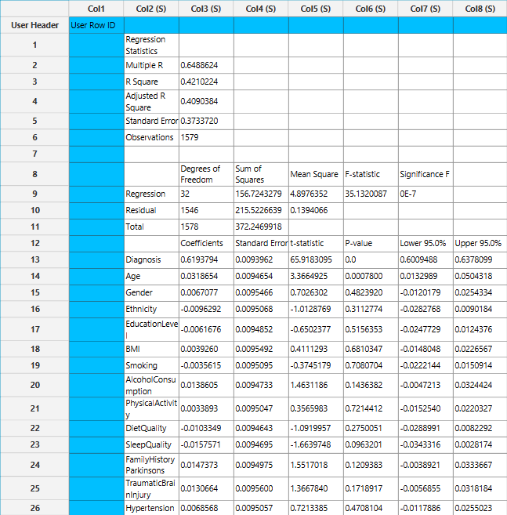

Step 7: Feature Selection: Train set
We need to select the features of the train set that the regression analysis indicated. Create a new tab by pressing the “+” button on the bottom of the page with the name “FEATURE_SELECTION_TRAIN”.
Import data into the input spreadsheet of the “FEATURE_SELECTION_TRAIN” tab from the output of the “NORMALIZE_TRAIN_SET” tab by right-clicking on the input spreadsheet and then choosing “Import from Spreadsheet”.
Select the columns that correspond to the important features: Data Transformation $→$ Data Manipulation $→$ Select Column(s)
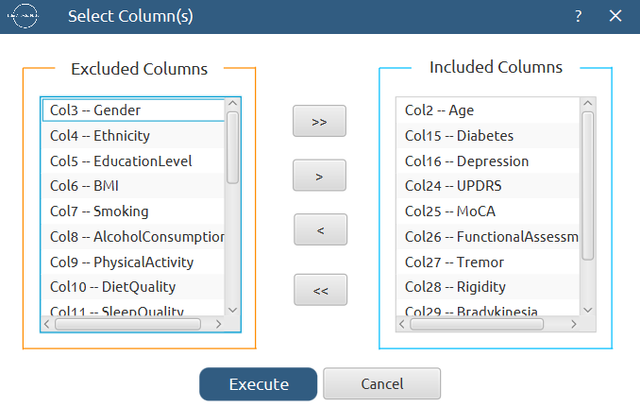
The results will appear on the output spreadsheet.

Step 8: Feature Selection: Test set
We need to select the features of the test set that the regression analysis indicated. Create a new tab by pressing the “+” button on the bottom of the page with the name “FEATURE_SELECTION_TEST”.
Import data into the input spreadsheet of the “FEATURE_SELECTION_TEST” tab from the output of the “NORMALIZE_TEST_SET” tab by right-clicking on the input spreadsheet and then choosing “Import from Spreadsheet”.
Select the columns that correspond to the important features: Data Transformation $→$ Data Manipulation $→$ Select Column(s)
The results will appear on the output spreadsheet.

Step 9: Train the model
Create a new tab by pressing the “+” button on the bottom of the page with the name “TRAIN_MODEL(.fit)”.
Import data into the input spreadsheet of the “TRAIN_MODEL(.fit)” tab from the output of the “FEATURE_SELECTION_TRAIN” tab by right-clicking on the input spreadsheet and then choosing “Import from Spreadsheet”.
Use the J48 decision tree method to train and fit the model: Analytics $→$ Classification $→$ J48 Decision Tree
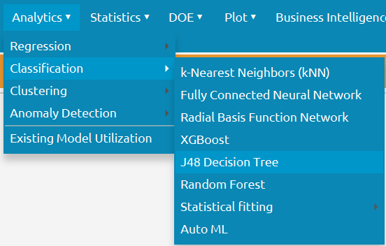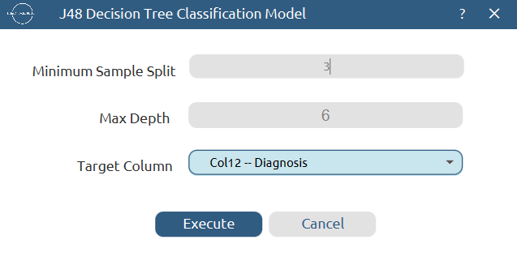

The predictions will appear on the output spreadsheet.
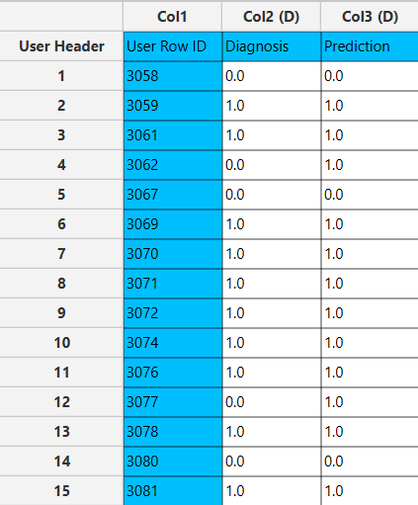

Step 10: Validate the model
Create a new tab by pressing the “+” button on the bottom of the page with the name “VALIDATE_MODEL(.predict)”.
Import data into the input spreadsheet of the “VALIDATE_MODEL(.predict)” tab from the output of the “FEATURE_SELECTION_TEST” tab by right-clicking on the input spreadsheet and then choosing “Import from Spreadsheet”.
To validate the model: Analytics $→$ Existing Model Utilization$→$ Model (from Tab:) TRAIN_MODEL(.fit). Choose the column “Diagnosis” to be transferred to the output spreadsheet.
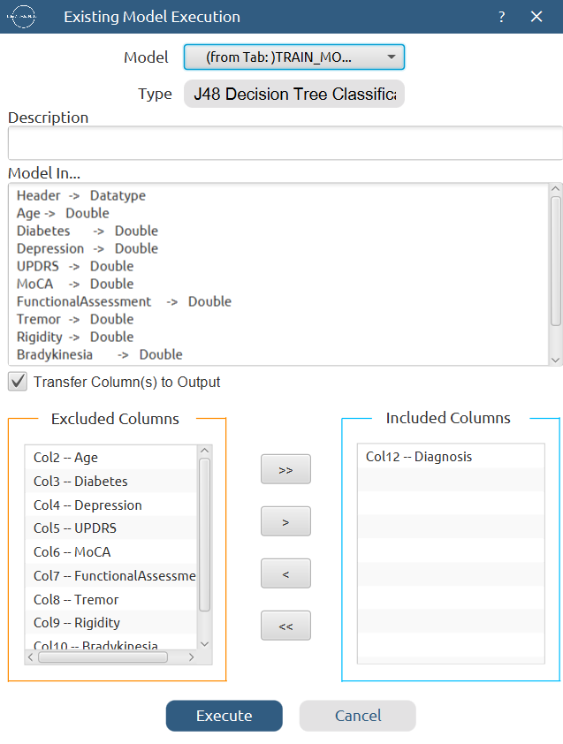

The predictions will appear on the output spreadsheet.
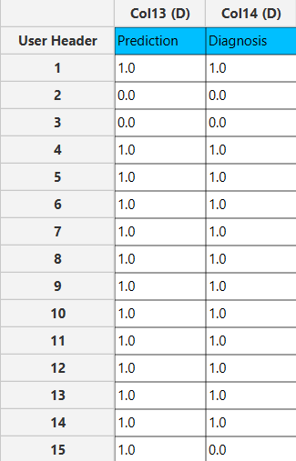

Step 11: Statistics calculation
Create a new tab by pressing the “+” button on the bottom of the page with the name “STATISTICS_ACCURACIES”.
Import data into the input spreadsheet of the “STATISTICS_ACCURACIES” tab from the output of the “VALIDATE_MODEL(.predict)” tab by right-clicking on the input spreadsheet and then choosing “Import from Spreadsheet”.
Calculate the statistical metrics for the classification: Statistics $→$ Model Metrics $→$ Classification Metrics
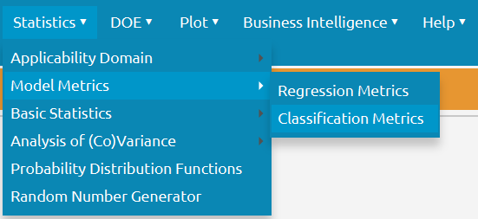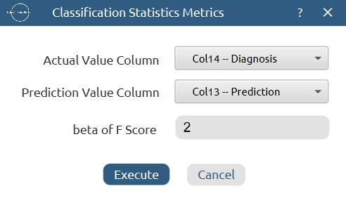

The results will appear on the output spreadsheet.
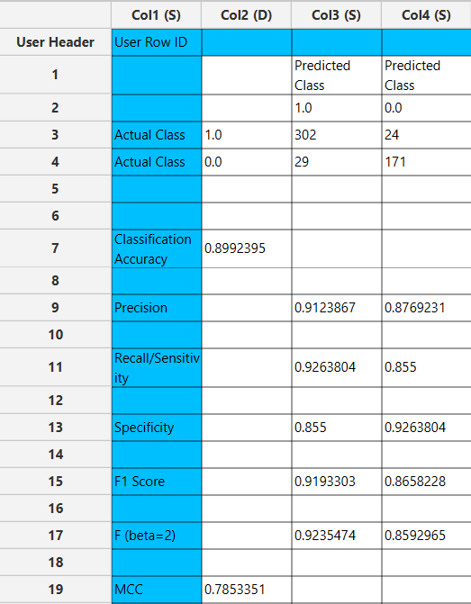

Step 12: Reliability check for each record of the test set

Step 12.a: Create the domain
Create a new tab by pressing the “+” button on the bottom of the page with the name “EXCLUDE_DIAGNOSIS”.
Import data into the input spreadsheet of the “EXCLUDE_DIAGNOSIS” tab from the output of the “FEATURE_SELECTION_TRAIN” tab by right-clicking on the input spreadsheet and then choosing “Import from Spreadsheet”.
Manipulate the data to exclude the target column “Diagnosis”: Data Transformation $→$ Data Manipulation $→$ Select Column(s)
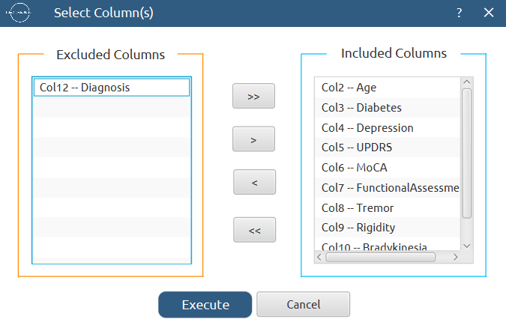

The results will appear on the output spreadsheet.
Create a new tab by pressing the “+” button on the bottom of the page with the name “DOMAIN”.
Import data into the input spreadsheet of the “DOMAIN” tab from the output of the “EXCLUDE_DIAGNOSIS” tab by right-clicking on the input spreadsheet and then choosing “Import from Spreadsheet”.
Create the domain: Statistics $→$ Applicability Domain $→$ APD
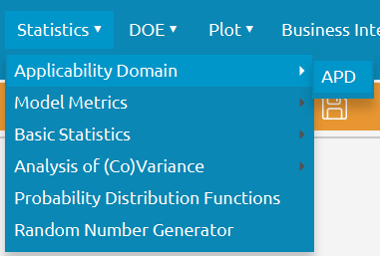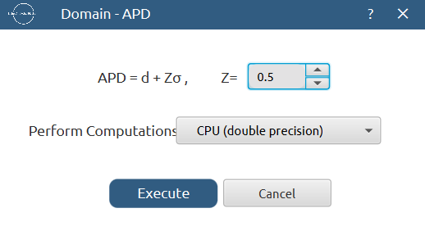

The results will appear on the output spreadsheet.
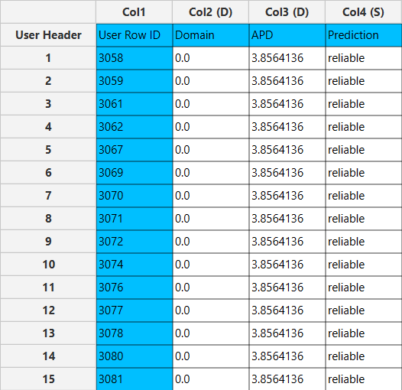

Step 12.b: Check the test set reliability
Create a new tab by pressing the “+” button on the bottom of the page with the name “EXCLUDE_DIAGNOSIS_TEST_SET”.
Import data into the input spreadsheet of the “EXCLUDE_DIAGNOSIS_TEST_SET” tab from the output of the “FEATURE_SELECTION_TEST_SET” tab by right-clicking on the input spreadsheet and then choosing “Import from Spreadsheet”.
Manipulate the data to exclude the target column “Diagnosis”: Data Transformation $→$ Data Manipulation $→$ Select Column(s)

The results will appear on the output spreadsheet.
Create a new tab by pressing the “+” button on the bottom of the page with the name “RELIABILITY”.
Import data into the input spreadsheet of the “RELIABILITY” tab from the output of the “EXCLUDE_DIAGNOSIS_TEST_SET” tab by right-clicking on the input spreadsheet and then choosing “Import from Spreadsheet”.
Check the Reliability: Analytics $→$ Existing Model Utilization$→$ Model (from Tab:) DOMAIN
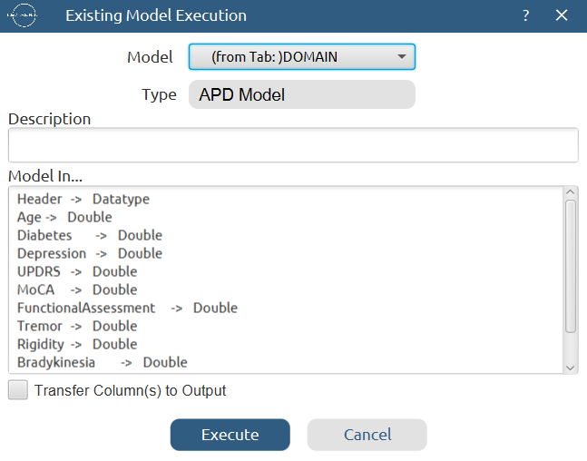

The results will appear on the output spreadsheet.
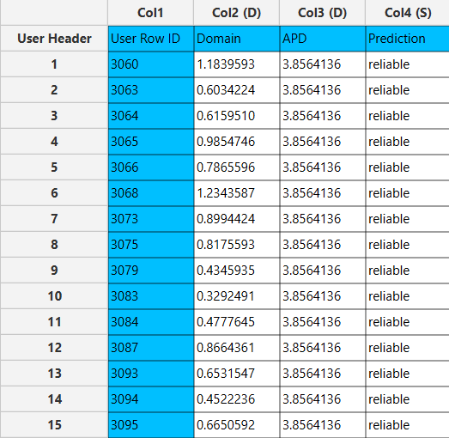

Final Isalos Workflow
Following the above-described steps, the final workflow on Isalos will look like this:
